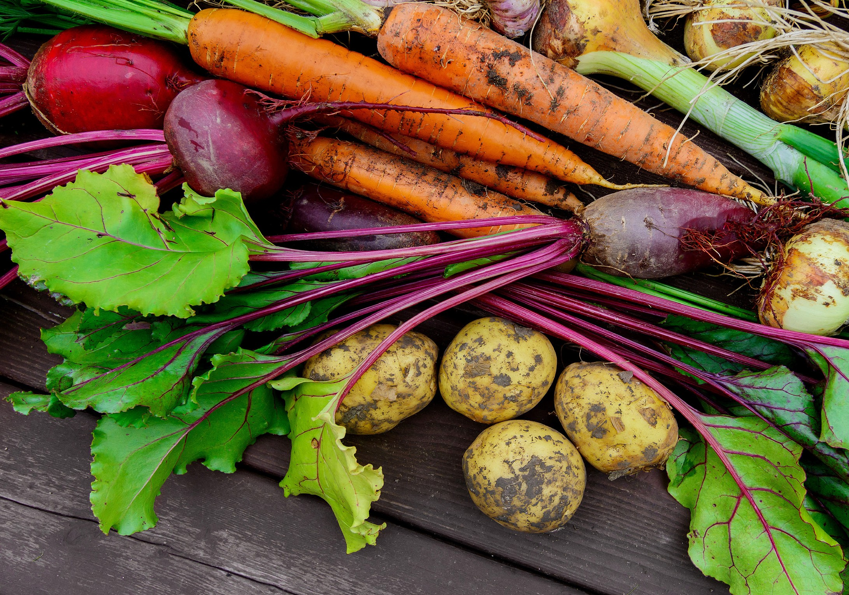

HARVEST

THE
CR A N M E R G R O U P

TO KNOW CHRIST BETTER AND TO MAKE HIM BETTER KNOWN

Welcome

Opening Prayer
God of harvest time,
we gather together today as Your people and Your church, to celebrate and to give thanks
for the harvest we have been fortunate enough to share in. Enable us to be fruitful in our worship,
and to praise You with joyful hearts

Amen

Hymn

Come, Ye Thankful People, Come
H.Alford, © Jubilate Hymns.
Come, ye thankful people, come, Raise the song of harvest home; All is safely gathered in,
Ere the winter storms begin; God, our Maker, doth provide For our wants to be supplied;
Come to God’s own temple, come; Raise the song of harvest home.
All this world is God’s own field, Fruit unto His praise to yield; Wheat and tares therein are sown, Unto joy or sorrow grown; Ripening with a wond’rous power Till the final harvest-hour;
Grant, O Lord of life, that we Holy grain and pure may be.

Come, then, Lord of mercy, come, Bid us sing Thy harvest-home;
Let Thy saints be gathered in, Free from sorrow, free from sin; All upon the golden floor Praising Thee for evermore;
Come, with all Thine angels, come Bid us sing Thy harvest home.

Confession and Absolution
We confess our sin, and the sins of our society, in the misuse of God’s Creation.
God our Father, we are sorry
for the times when we have used your gifts carelessly, and acted ungratefully.
Hear our prayer, and in your mercy:

forgive us and help us.
We enjoy the fruits of the harvest,
but sometimes forget that you have given them to us. Father, in your mercy:

forgive us and help us.
We belong to a people who are full and satisfied, but ignore the cry of the hungry.
Father, in your mercy:

forgive us and help us.
We are thoughtless,
and do not care enough for the world you have made. Father, in your mercy:

forgive us and help us.

We store up goods for ourselves alone, as if there were no God and no heaven. Father, in your mercy:

forgive us and help us.

May the God of love and power
forgive you and free you from your sins, heal and strengthen you by his Spirit,
and raise you to new life in Christ our Lord.

Amen.

Prayer of Thanksgiving

Almighty and everlasting God, we offer you our grateful thanks
for your fatherly goodness and care in giving us your gifts and the fruits of the earth through the seasons.

Give us grace to use them rightly, to your glory, for our own wellbeing,
and for the relief of those in need; through Jesus Christ our Lord.

Amen.

Bible Reading

St. Matthew’s Gospel, chapter 7, verses 7-12.

Ask, Seek, Knock
Jesus said, “Ask and it will be given to you; seek and you will find; knock and the door will be opened to you. For everyone who asks receives; the one who seeks finds; and to the one who knocks, the door will be opened.
“Which of you, if your son asks for bread, will give him a stone? Or if he asks for a fish, will give him a snake? If you, then, though you are evil,
know how to give good gifts to your children, how much more will your Father in heaven give good gifts to those who ask him! So in everything, do to others what you would have them do to you, for this sums up the Law and the Prophets.”

Address

Hymn
During which the congregation is invited to bring forward donations of produce, in support of local charities.

For the Beauty of the Earth
Folliott Pierpoint, © 1986 Horrobin/Leavers.
For the beauty of the earth, For the glory of the skies,
For the love which from our birth Over and around us lies:
Lord of all, to Thee we raise This our sacrifice of praise.
For the beauty of each hour Of the day and of the night,
Hill and vale and tree and flower, Sun and moon and stars of light:
Lord of all, to Thee we raise This our sacrifice of praise.
For the joy of human love, Brother, sister, parent, child,
Friends on earth and friends above, Pleasures pure and undefiled:
Lord of all, to Thee we raise This our sacrifice of praise.
For each perfect gift of Thine, To our race so freely given, Graces, human and divine,
Flowers of earth and buds of heaven:
Lord of all, to Thee we raise This our sacrifice of praise.

For thy Church which evermore, Lifteth holy hands above, Offering up on every shore,
Her pure sacrifice of love,

Lord of all, to Thee we raise This our sacrifice of praise.

Offertory Prayers
God, our Creator,

You give us bread from the earth, and bread from heaven. We bring before You now our offering,
In gratitude for all that You have given to us, Especially the gift of Your Son, Jesus Christ.

We pray that You will use these, our tokens, For the purposes of Your Kingdom,
And to Your glory. In Jesus’ name, Amen.

Intercessory Prayers
Concluding with the Lord’s Prayer.
As our Saviour taught us, so we pray together:

Our Father in heaven, hallowed be Your name, Your kingdom come, Your will be done,
on earth as in heaven.

Give us today our daily bread. Forgive us our sins,
as we forgive those who sin against us. Lead us not into temptation,

but deliver us from evil.
For the kingdom, the power, and the glory are Yours

now and for ever, Amen.

Hymn

We Plough the Fields and Scatter
Matthias Claudius, tr. Jane Montgomery Campbell, altered © 1986 Horrobin/ Leavers.
We plough the fields and scatter The good seed on the land,
But it is fed and watered By God’s almighty hand;
He sends the snow in winter, The warmth to swell the grain, The breezes and the sunshine And soft refreshing rain.
All good gifts around us are sent from heaven above, Then thank the Lord, O thank the Lord, for all His love.
He only is the maker
Of all things near and far;
He paints the wayside flower, He lights the evening star;
The wind and waves obey Him, By Him the birds are fed; Much more to us, His children, He gives our daily bread.
All good gifts around us are sent from heaven above, Then thank the Lord, O thank the Lord, for all His love.
We thank You, then, O Father, For all things bright and good, The seed-time and the harvest, Our life, our health, our food.
Accept the gifts we offer For all Your love imparts;
We come now, Lord, to give You Our humble, thankful hearts.
All good gifts around us are sent from heaven above, Then thank the Lord, O thank the Lord, for all His love.

Blessing
May God the Father bless you,
who first sowed the seed of eternal life in your hearts. May God the Son bless you,
who nurtures you with the rain and sunshine of love. May God the Spirit bless you,
who brings us all to fruition;
and may the blessing of God Almighty
be among you and remain with you always.

Amen.

Go in peace to love and serve the Lord.

In the Name of Christ, Amen.
As you leave the church, please do give financially if you’re able, to the work of Christian Aid and Tearfund, the development & relief charities,. Your offering here, and that from our Orston Harvest Service, will be split equally between them. Your donations of produce will be given to The Friary, www.the-friary.org.uk, a charity operating in the Nottingham area, which empowers homeless and disadvantaged adults to rebuild their lives by providing practical services, advice and emotional support. Thank you so much for your support.

Forthcoming 10am Sunday Services:
11th Oct. - St.Thomas’ Aslockton; 18th Oct. - St. John’s Whatton; 25th Oct. - St. Mary’s Orston
For details of all our services, in church and online, go to www.cranmergroup.org.uk Your Vicar: Rev.Tim Chambers | vicar@cranmergroup.org.uk | 01949 850523

THE

CR A N M E R GR O U P
TO KNOW CHRIST BETTER AND TO MAKE HIM BETTER KNOWN
All songs covered by the CCLI have been reproduced under CCL number 2258639. Common Worship material included herein is copyright © the Archbishops’ Council 2006. Additional liturgy from the Arthur Rank Centre (www.arthurrankcentre.org.uk).

